DSA & Problems
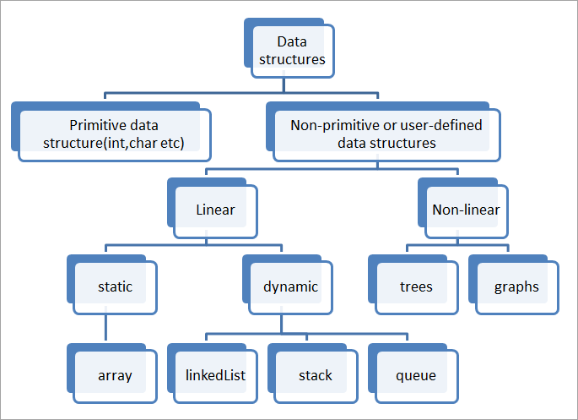

Linear:
- Storage Structure - Array(static), List(Dynamic Array), Linkedlist
- Behavioural - Stack, Queue
Non-Linear:
- Hierarchical Structure – Trees
- Relational Structure – Graph
- Priority based Structure – Heap
- Dictionay based Structure – Hash
  - For Fast LookUP

Trees, Graphs, HashMap, Heap

Array, String – Primitive/Built in in C/C++(low level languages) & Non Primitive in Java/Python(High level languages)

Data Structures
- LL
  - Common operations: insert, delete, remove, reverse,..
    - Find the middle, using slow and fast pointers
  - Algorithms based on LL
  - Use cases:
    - Used in music playlist
    - Keeping track of processes, history in web browsers

Miscellaneous
Ooho:

Aps + Basic coding
Source: Career ride + IndiaBix, Interviewbit

Aps
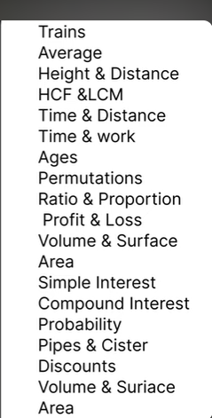

Basic coding - C Based DSA
Order Precedence:
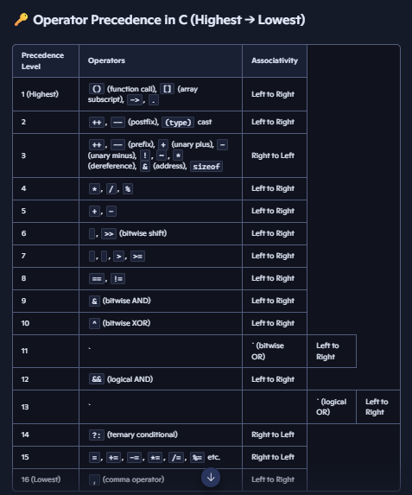
Data types:
int,float
double
char
void
String literal – created with pointer – a text stored in read only memory; not modifiable, but can be accessed through pointer.
String – the same text stored in a data structure as string data type; modified, processed – for usage
Arrow Operator – a pointer for structure
Struct structure *ptr = &s1;
ptr->id =same as= (*ptr).id
memory layout of fields in struct
L value and R value
L value – Locator value – has an address, can be modified.
R value – Read value – temporary value(usually appears on the left side of assignment), can’t be modified.
Union
- union takes the size of its largest member

Pointers
Pointer size – 4 byte(32 bit) and 8 byte(64 bit)
Pointer increment/decrement - moves to the next/previous element(not the address unit).

